Nepal Manuscripts Return Home After Conservation in Heidelberg
More than 800 rare documents from Nepal—some dating back to the 13th century—have been formally returned to the country after years of conservation and research work in Germany.
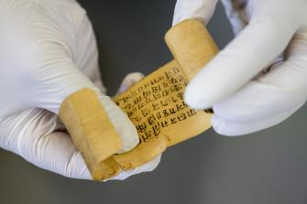
A palm leaf roll from the collection – Ⓒ Philipp Rothe
The collection, assembled by Bavarian collector Josef Peter Walter Rindfleisch between 1980 and 2000, had been entrusted to the Indologist Prof. Dr. Axel Michaels of Heidelberg University with the explicit aim of eventual repatriation. On 24 April 2026, representatives of the Nepali government officially received the materials at a ceremony in Heidelberg. The agreement was signed by Sagar Phuyal, chargé d’affaires a.i. of Nepal’s embassy in Berlin and Prof. Dr. Axel Michaels.
Scholars say the holdings are likely one of the largest collections of Nepalese palmleaf rolls outside Nepal. At its core are 465 Newari palm-leaf rolls, most of them bearing clay seals and dating to the medieval Malla period (c. 1200–1800). The archive also includes royal decrees, court records, Sanskrit manuscripts, and a wide range of historical materials—from legal documents and ritual texts to photographs, maps, and personal writings. Fifteen bound volumes in the collection document palace life, state expeditions, and official correspondence from the 19th and early 20th centuries.
“This collection offers a unique window into Nepal’s political, legal, and religious history across several centuries,” said Michaels, who heads the project “Documents on the History of Religion and Law of Pre-modern Nepal” at the Heidelberg Academy of Sciences and Humanities.
When the manuscripts first arrived in Heidelberg, their provenance was only partially documented, and many items were in poor condition. Mold, insect damage, and earlier repair attempts had left visible traces. Conservation specialists carried out extensive restoration work: fragile palm-leaf scrolls were humidified, carefully opened, cleaned, repaired, and digitized before being rolled again and placed in acid-free archival storage.
The project received support in 2022 from the Flagship Initiative “Transforming Cultural Heritage” (FI TCH), enabling systematic cataloguing and digitization. Today, the collection is accessible online via Heidelberg University Library and integrated into the Documenta Nepalica research database. An open access cataogue of metadata of the collection will soon be released from Heidelberg University Publishing.

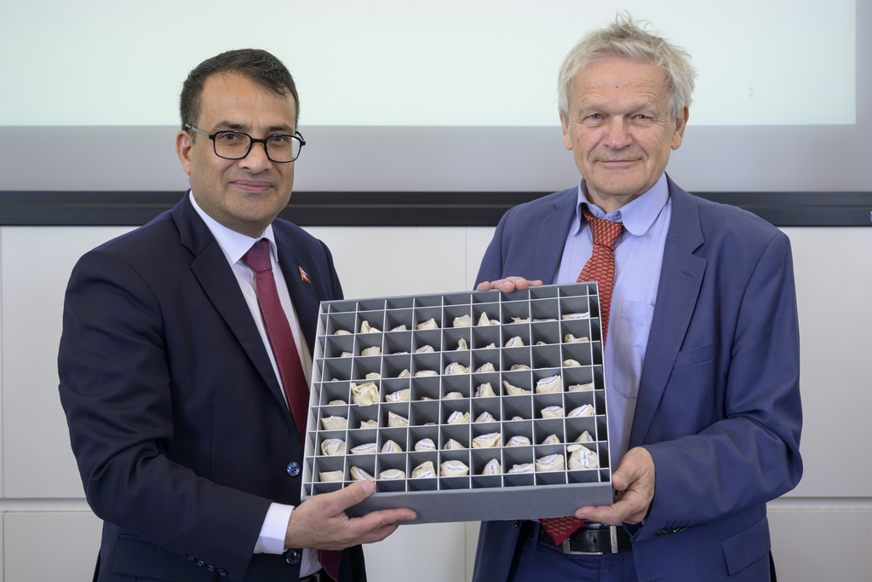
Chargé d’Affaires a.i. Sagar Phulal and Prof. Axel Michaels – Ⓒ Philipp Rothe
As part of the handover event, Dr. Manik Bajracharya and Dr. Rajan Khatiwoda offered insights into the collection. Both are leading scholars in the research project “Documents on the History of Religion and Law of Pre-modern Nepal,” based at the Heidelberg Academy of Sciences and Humanities. Prof. Dr. Christiane Brosius, a researcher at the Heidelberg Center for Transcultural Studies, presented the “Nepal Heritage Documentation Project”, which systematically records endangered cultural assets in Nepal—such as temples, monasteries, palaces, and inscriptions—and makes them digitally accessible. Welcoming remarks were delivered by Prof. Dr. Marc-Philippe Weller, Vice-Rector for International Affairs and Diversity, and Prof. Dr. Hans Harder, Director of the South Asia Institute.
Receiving the manuscripts, CDA a.i. Mr. Phuyal expressed sincere appreciation to
Professor Dr. Michaels and all individuals involved in the preservation and repatriation process. He highlighted that this gesture reflects a deep respect for Nepal’s cultural heritage and contributes significantly to the country’s ongoing efforts to recover and safeguard its historical assets.
For Michaels, the dual approach—digital access and physical return—was essential. “Making the materials available worldwide is one goal,” he said. “But returning them to Nepal is equally important. It acknowledges their cultural significance and our responsibility toward their history.”
With the handover, a substantial body of Nepal’s written heritage will be returned home – preserved for future generations, yet accessible to researchers around the world.

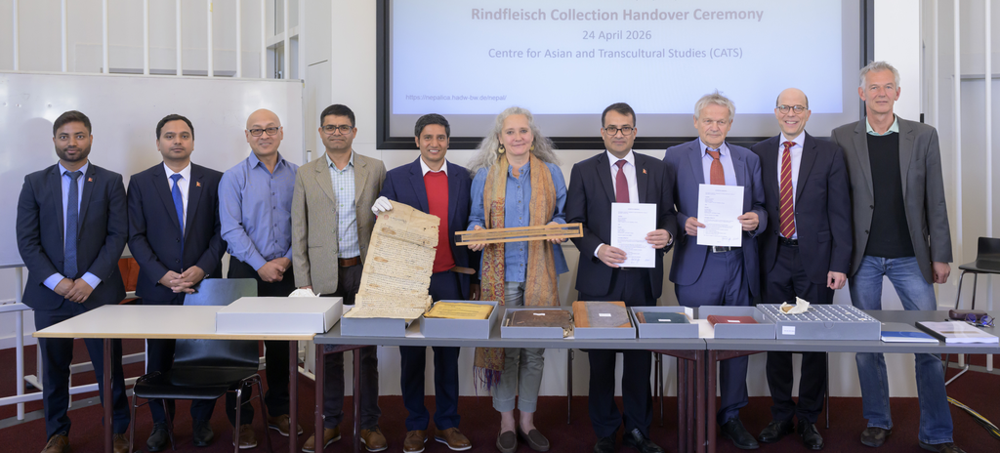
Ranjan Yadav (1st Secretary), Dipendra Sah (3rd Secretary),* Dr. Mani Bajracharya, *Dr. Ramhari Timalsina, *Dr. Rajan Khatiwoda, Prof. Christiane Brosius (Director Nepal Heritage Documentation Project), Chargé d’Affaires a.i. Sagar Phuyal, *Prof. Axel Michaels, Prorektor Marc-Philippe Weller, Prof. Hans Harder (Director South Asia Institute) – Ⓒ Philipp Rothe

* Members of the Nepal Research Unit at Heidelberg Academy of Sciences and Humanities

